Quest 225 Compressor GMCC conversion
Overview: The Quest 225 originally made with a Rechi or LG brand compressor requires some modifications to install the available GMCC brand compressor.
Parts:
- 4043474 COMPRESSOR
- 4037332 SUCTION TUBE
- 4043476 TERMINAL COVER
- 4043477 GASKET
- 4020530 GROMMET X3
- 4020531 SLEEVE X3
- 4033032-04 CAPACITOR
- 4031519 P-CLAMP
- 1154006 BOLT SHORT X6
- 1154014 BOLT LONG x3
- 1282497 WASHER X 4
- 1107004 ¼-20 SCREW X 7
Tools:
- Needle Nose Pliers
- ¼ Hex Bit
- 5/16 Hex Bit
- 3/8 Hex Bit
- 7/16 Hex Bit
- 3/16 Drill Bit
- Drill
- Pipe cutter

Instructions:
- Disconnect power from unit.
- Using pliers grab the black humidity control knob and pull off. (Red Arrow)
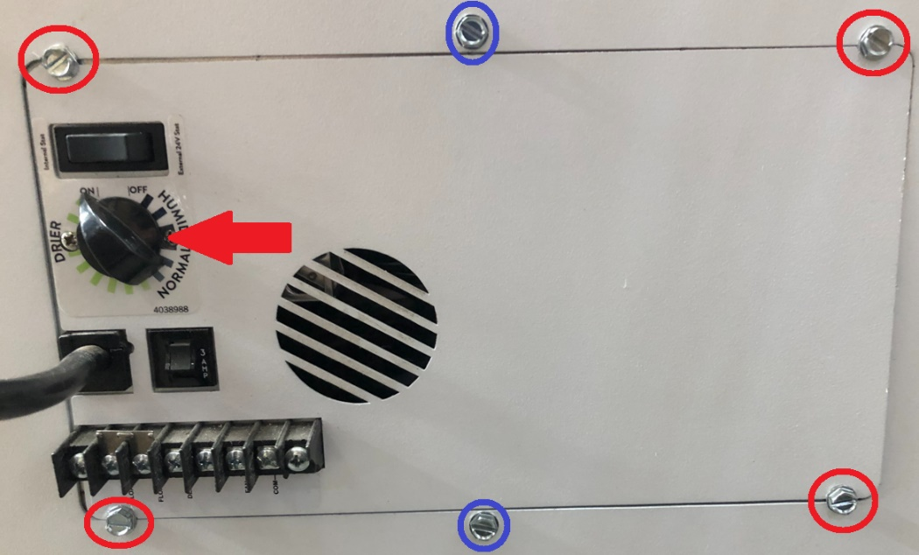
- Remove the 4 - 5/16 hex screws near the corners of the electrical box cover. (Red Circle)
- Remove electrical box cover.
- Remove these screws to remove the rear angled panel and top cover.
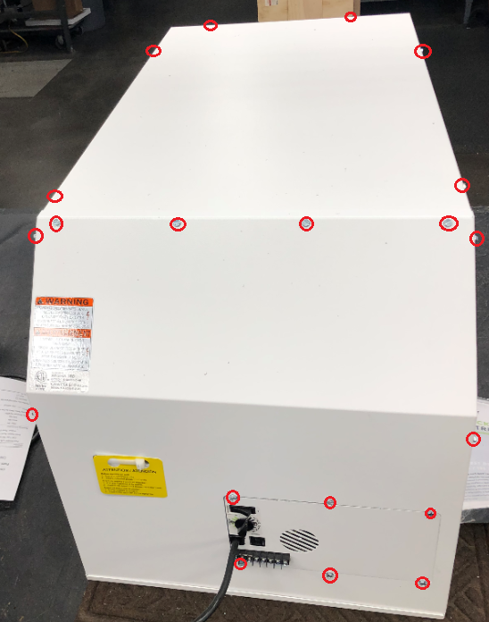
- Remove compressor cover panel by unscrewing 2 wingnuts.
- Remove 4 screws that hold in fan assembly and p-clamp for harness (red arrow).
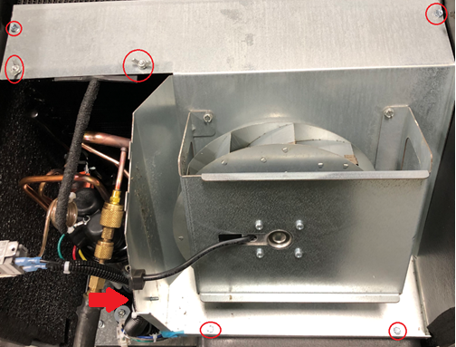
- Remove fan assembly from the unit.
- Remove nut holding cap on top of compressor. Remove cap and wires. Save nut.
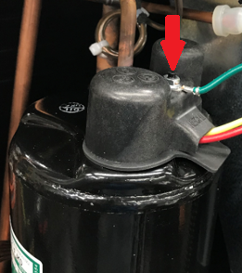
- Remove side panel by drill 7 rivets
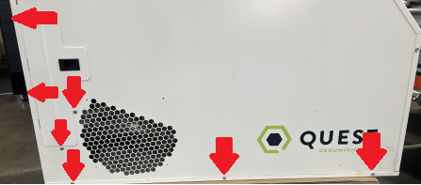
- Locate brass access valve on suction line and recover any remaining refrigerant.
- Remove suction line p-clamp at evaporator coil. Save plastic washer located behind p-clamp.
- Remove defrost t-stat from suction line if present. (7/21 and older)
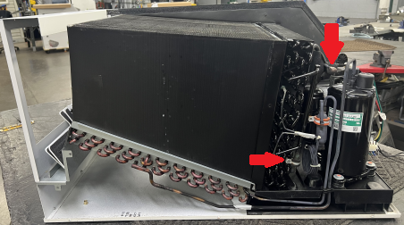
- Un-braze compressor, suction line and access port. Save access port but discard process stub, compressor, and suction line.
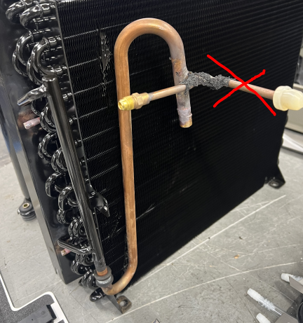
- Remove compressor from unit. Discard Grommets, sleeves, bolts, cap and gasket.
- If present remove original compressor adapter plate.
- Install new compressor adapter plate using short 3/8” bolts. 3-6 bolts will used depending on the inserts in drain pan available.
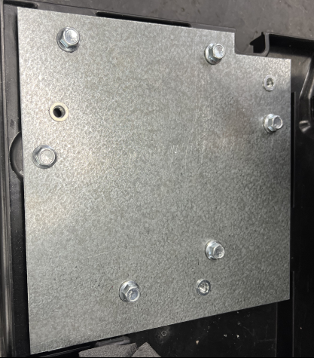
- Install new grommet and sleeves on compressor.
- Install compressor using 3 long bolts and 4 washers into new inserts. The rear bolt has 2 washers for clearance.
- Make sure the compressor is not hitting fan shroud or evaporator. If so, loosen the plate and/or compressor mounting bolts to reposition. There is some adjustment built into the holes to shift the compressor position.
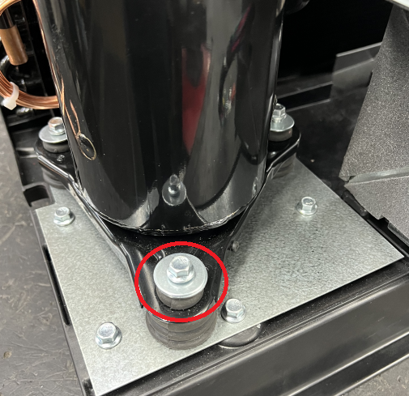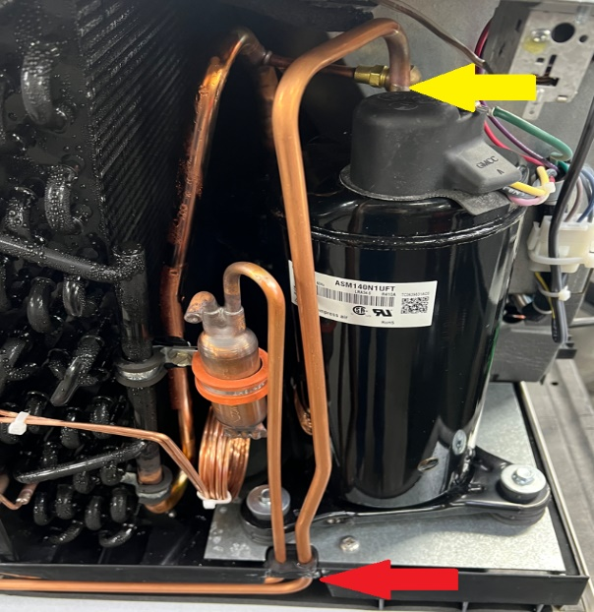
- Adjust discharge line by cutting off some of the tube (yellow arrow). Adjust length so that the tubes pass thru grommet correctly (red arrow). See above picture.
- Braze in new compressor using new suction line and access port as shown. See Above picture.
- Install defrost t-stat on suction line if present. Black tape not required.
- Install p-clamp and rivet on suction to evaporator coil.
- Evacuate, vacuum down and charge unit to specification on serial tag.
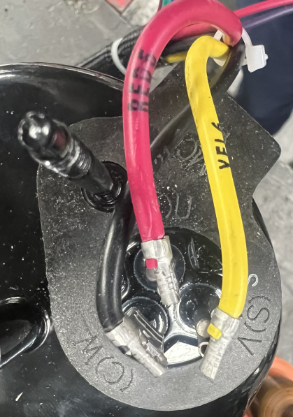
- Using new cap, overload and gasket install wires on compressors. Note R & S location may be swapped. No overload on this compressor
  - Red to R
  - Yellow to S
  - Black to C

- Remove old Compressor Capacitor and install new Compressor Capacitor with new P-clamp.
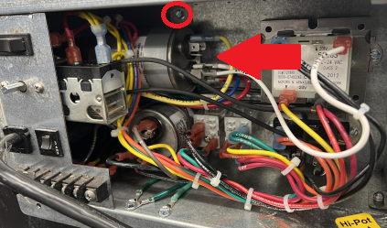
- Re-Install fan assembly and panels in reverse order. Use ¼ -20 self-threading screws in place of rivets.
- Repair complete

